Lesson 4: Step counter

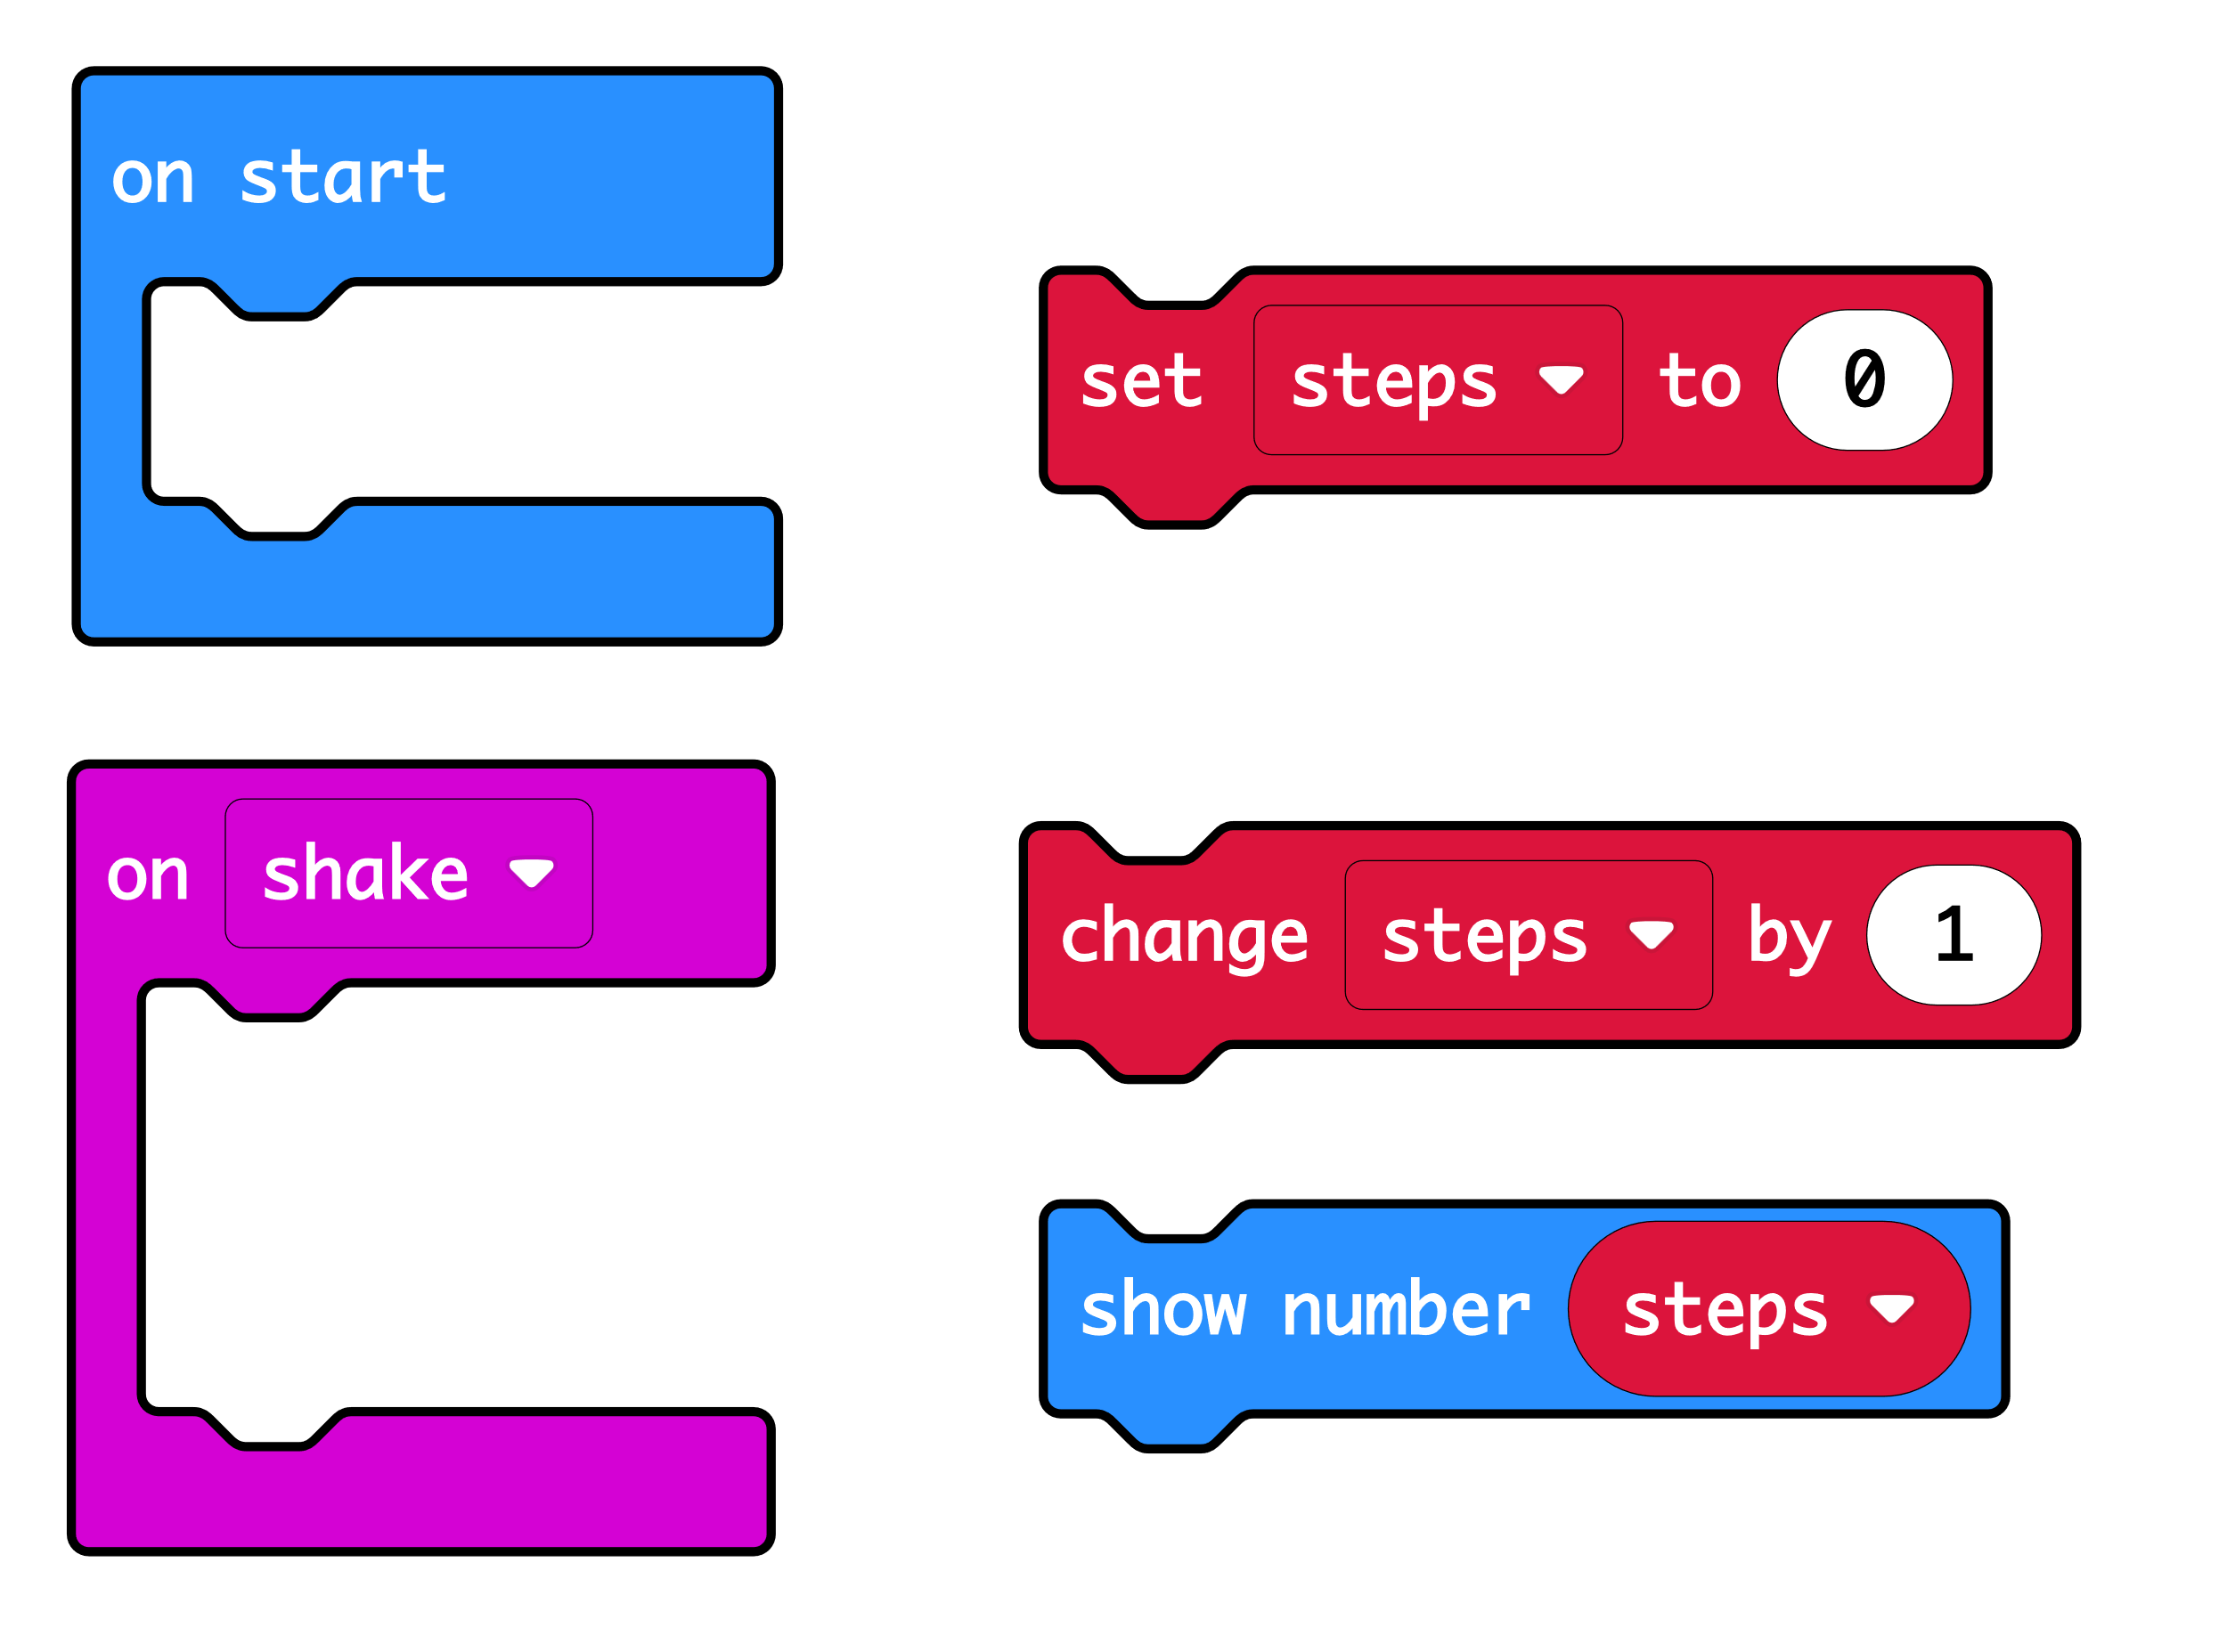
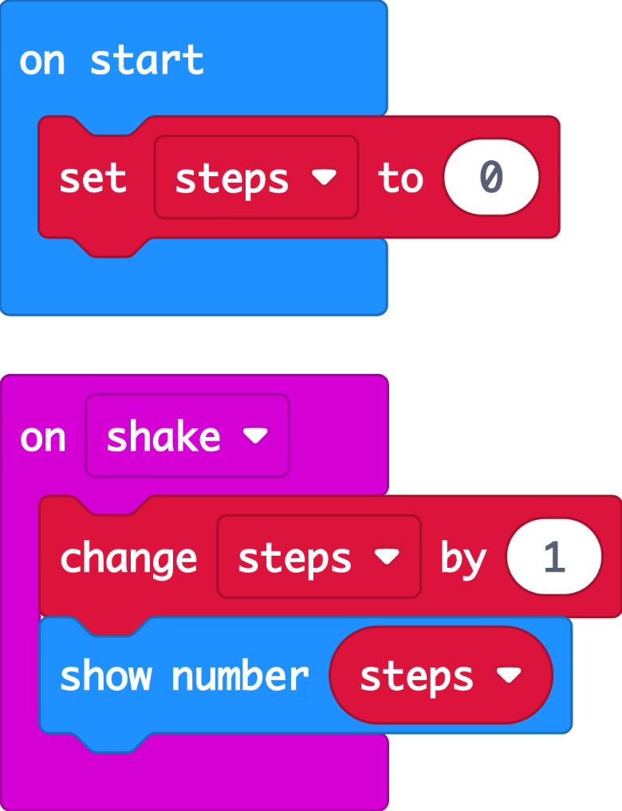
At the start, the code sets a variable called ‘steps’ to 0.

The ‘steps’ variable keeps track of how many steps we’ve taken.

When the accelerometer input senses a shake, the ‘change’ block adds 1 to the number stored in the ‘steps’ variable.

After the ‘steps’ variable is updated, ‘show number’ displays the new count on the LED display output.

